

**DEPARTMENT OF ELECTRONICS AND COMMUNICATION ENGINEERING**

**Academic Year**

**2023 – 2024 (ODD Semester)**

## MINI PROJECT REPORT

**R19CS652 Database Technologies**

**R19CS203 Object Oriented Programming Using Java**

**STUDENT ATTENDANCE SYSTEM**

| ***Submitted by,*** | ***Mentored by,*** |
| --- | --- |
| ***[*722822106131] Sabhareeswaran.S**  ***[*722822106164] Sri Krishna.M**  ***[*722822106186] Vigneshkumar.R** |  |

|  | **TABLE OF CONTENTS** | |  |
| --- | --- | --- | --- |
| **CHAPTER NO.** | **TITLE** | | **PAGE NO.** |
|  | **ABSTRACT** | | **i** |
|  | **LIST OF TABLES** | | **ii** |
|  | **LIST OF FIGURES** | | **iii** |
| **1** | **INTRODUCTION** | |  |
|  | 1.1 | OBJECTIVES |  |
|  | 1.2 | SCOPE OF THE PROJECT |  |
| **2** | **SYSTEM ANALYSIS AND SPECIFICATION** | |  |
|  | 2.1 | PROBLEM DESCRIPTION |  |
|  | 2.2 | FUNCTIONAL REQUIREMENT - HARDWARE & SOFTWARE |  |
|  | 2.3 | NON – FUNCTIONAL REQUIREMENT |  |
| **3** | **SYSTEM DESIGN** | |  |
|  | 3.1 | ER DIAGRAM |  |
|  | 3.2 | SCHEMA DIAGRAM |  |
| **4** | **PROPOSED SOLUTION** | |  |
|  | 4.1 | USER INTERFACE DESIGN |  |
|  | 4.2 | CLASS CONSTRUCTION |  |
|  | 4.3 | DATABASE CREATION |  |
| **5** | **PROJECT DESCRIPTION** | |  |
|  | 5.1 | MODULE DESCRIPTION |  |
|  | 5.2 | JDBC CONNECTIVITY |  |
| **6** | **IMPLEMENTATION** | |  |
| **7** | **RESULTS AND DISCUSSION** | |  |
| **8** | **CONCLUSION & FUTURE ENHANCEMENT** | |  |
|  | **REFERENCES** | |  |

# ABSTRACT

The Student Attendance Management System is an innovative and comprehensive solution designed to streamline and automate the process of recording, tracking, and managing student attendance in educational institutions. This system aims to replace traditional manual attendance tracking methods with a more efficient and accurate automated system.The proposed system leverages web-based platforms, to create a seamless and user-friendly experience for both students and administrators.

# CHAPTER 1 INTRODUCTION

* 1. **OBJECTIVES**

The primary objective of the Student Attendance Management System project is to establish a user-friendly online platform that significantly enhances the overall attendance tracking experience. This involves ensuring heightened accessibility and operational efficiency in attendance recording, student enrollment processes, and progress monitoring. The specific goals include developing a centralized system that empowers instructors to seamlessly record and organize student attendance, enables students to easily enroll and access attendance-related information, and allows administrators to oversee the entire attendance management process. The ultimate aim is to cater to the diverse needs of educational institutions and training organizations seeking an advanced solution to efficiently monitor and manage student attendance records.

# SCOPE OF THE PROJECT

* The scope of the Student Attendance Management System project encompasses the development of a comprehensive online platform designed to streamline and automate the recording and monitoring of student attendance in educational institutions.
* The system aims to provide a centralized platform where teachers can easily record and track student attendance, students can view their attendance records, and administrators can efficiently manage attendance data. The system will cater to the needs of educational institutions, including schools, colleges, and universities, seeking to enhance attendance tracking processes through technology.

# CHAPTER 2

**SYSTEM ANALYSIS AND SPECIFICATION**

# PROBLEM DESCRIPTION

The present state of student attendance management in educational institutions is characterized by various challenges, including manual and time-consuming processes, inaccuracies in attendance tracking, and a lack of a unified system for efficient administration. This project aims to tackle these issues by introducing a modern Student Attendance Management System, designed to be an intuitive and user-friendly solution. The primary goal is to improve accessibility, streamline attendance recording and monitoring, and offer a unified platform for seamless administration in educational institutions.

# FUNCTIONAL REQUIREMENT:

**SOFTWARE REQUIREMENT:**

* + - Java Development Kit (JDK):

Version 8 or higher to support JavaFX development.

* + - JavaFX Framework:

Required for building the intuitive frontend of the coffee vending machine.

* + - MySQL:

Relational database management system for seamless storage and retrieval of project data.

* + - Eclipse IDE:

Integrated Development Environment for Java, ensuring smooth integration and development.

# HARDWARE REQUIREMENT:

Processor, RAM, Storage, Display, Internet Connectivity, Peripheral Devices, Mobile Device Compatibility

# NON-FUNCTIONAL REQUIREMENT

* + - Performance and Responsiveness:

Ensure quick and responsive interfaces for efficient beverage customization and transaction processing.

* + - Security and Compliance:

Implement robust security measures to protect user data and transactions, ensuring compliance with industry standards.

* + - Scalability and Maintainability:

Design a scalable architecture to accommodate user growth and feature expansions, with clean code for easy maintenance.

* + - Accessibility and Internationalization:

Enhance accessibility features and support multiple languages for a diverse and inclusive user experience.

# CHAPTER 3 SYSTEM DESIGN

* 1. **ER DIAGRAM**

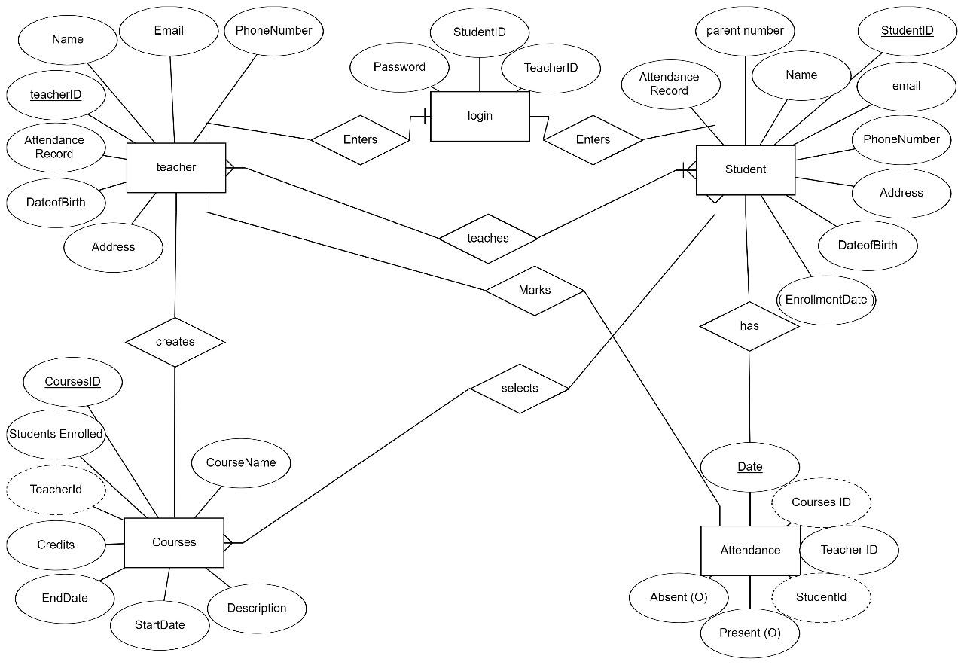

# SCHEMA DIAGRAM

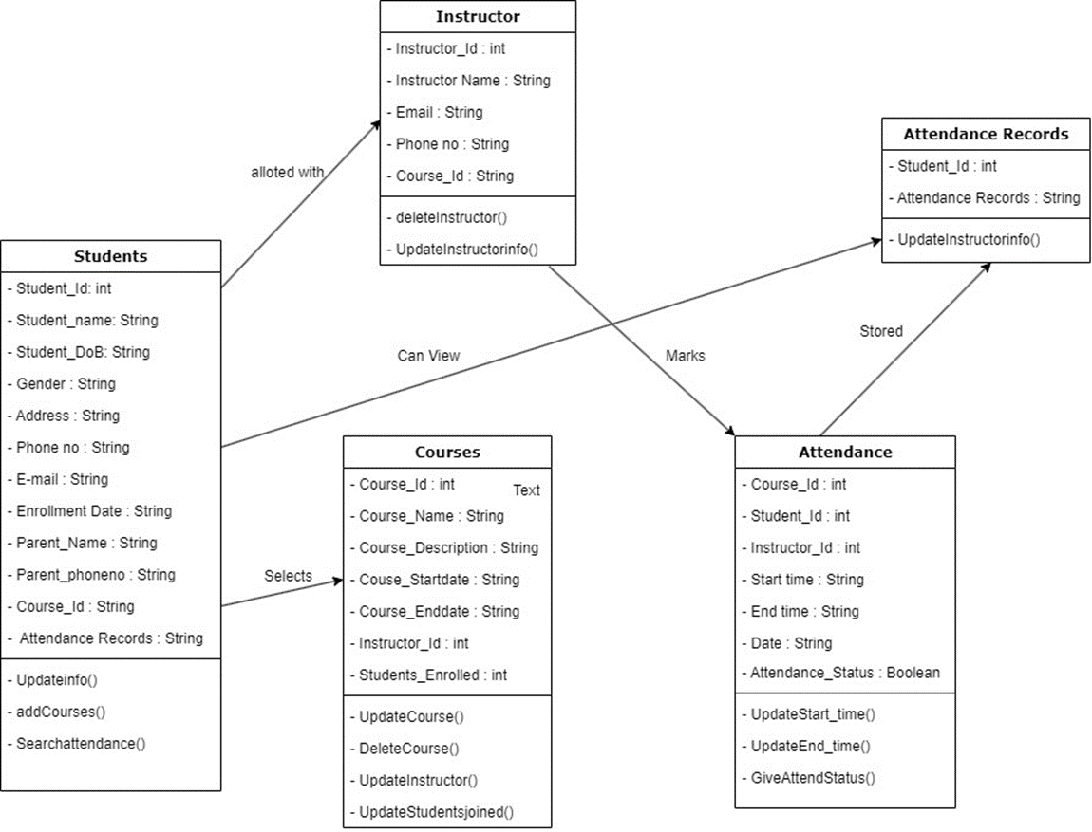

**CHAPTER 4 PROPOSED SOLUTION**

# USER INTERFACE DESIGN

Our UI design strategy utilizes Canva for visually striking templates and themes, enhancing the application's overall appeal. Simultaneously, SceneBuilder is employed to streamline JavaFX frontend development, ensuring practical implementation. This collaborative approach merges artistic elements from Canva with the practical implementation facilitated by SceneBuilder, aiming to deliver an intuitive, aesthetically pleasing, and user- friendly interface for the Student Attendance Management System.

# CLASS CONSTRUCTION

The proposed Student Attendance Management System comprises essential classes for seamless administration. The Login Class ensures secure user authentication, while the Attendance Class manages core functions such as recording and tracking attendance. The Communication Class facilitates transparent communication, and the Security Class ensures the confidentiality of attendance data. The Dashboard Class provides an intuitive interface for users, and the Administrator Class oversees system-wide activities. Together, these classes create a cohesive framework, addressing the varied needs of teachers, students, and administrators, thereby streamlining and enhancing the efficiency of student attendance management in educational institutions.

# DATABASE CREATION

The MySQL database schema for the Student Attendance Management System incorporates key tables to efficiently manage attendance-related data. The "Users" table stores user details, the "Attendance" table records attendance information, and the "Communications" table manages communication data. Interconnected through foreign keys, these tables support Create, Read, Update, and Delete (CRUD) operations, facilitating user roles, attendance tracking, and communication within the system.

# CHAPTER 5 PROJECT DESCRIPTION

* 1. **MODULE DESCRIPTION**

Welcome Module:

This module acts as the entry point for users, offering a welcome page with options to identify as a student or instructor. Students are directed to the main page, while instructors proceed to the sign-up page. Existing users can log in to their respective dashboards.

Signup/Login Module:

Students can sign up by providing necessary details, and upon successful registration, they can log in to access the main page. For instructors, the sign-up page allows them to create an account, while existing instructors can log in to access their dashboard.

Main Page Module:

Upon student login, the main page displays relevant information, including attendance statistics and upcoming events. Students can view their attendance history, request leave, and access additional resources. Instructors can navigate to their dashboard to manage attendance-related tasks.

Dashboard Module (Student):

Students can view their attendance records, track trends, and access additional resources from the dashboard. It provides a centralized view of their attendance history, displaying overall attendance percentage and any pending leave requests.

Profile Module (Student):

In the student's profile page, users can provide personal information, manage account details, and log out. This module ensures a personalized and secure user experience.

Dashboard Module (Instructor):

Instructors, upon login, access a dashboard displaying attendance statistics and options to manage classes. They can view overall attendance trends, handle leave requests, and generate attendance reports.

Add Class Module (Instructor):

Instructors can utilize this module to add new classes. It includes fields for class name, description, and schedule. This module is crucial for expanding the range of available classes.

Attendance Management Module (Instructor):

Instructors can mark attendance for each class, view detailed attendance reports, and manage leave requests. This module empowers instructors to maintain accurate attendance records and address attendance-related issues.

Leave Management Module (Instructor):

Instructors can handle student leave requests, approve or deny them, and maintain a log of approved leaves. This feature streamlines the leave approval process within the Student Attendance Management System.

Profile Module (Instructor):

Similar to the student profile module, instructors can manage their personal information, account details, and log out from their profile page.

View Class Page Module:

This module allows students to explore detailed information about a specific class post-enrollment. The view class page provides a comprehensive overview, including the class name, schedule, instructor details, and attendance history. Students can view attendance trends, submit leave requests, and engage in communication related to the class. The module incorporates a progress tracker for students to monitor their attendance and overall participation, enhancing their engagement within the Student Attendance Management System.

and assigned tests. Instructors can navigate to their dashboard to view existing courses.

# JDBC CONNECTIVITY

The Student Attendance Management System's Database Connectivity Project ensures a secure link to the MySQL database through JDBC. Modules include User Authentication for secure logins, Attendance Information Retrieval for dynamic display, and Enrollment and Progress Tracking for managing learner attendance. Instructors utilize the Class Management module for CRUD operations, while Leave Request Management handles student leave requests. Attendance Report Generation offers detailed insights, and Profile Management empowers users to update personal details. The Communication and Notification module enhances user engagement, and Discussion Forum Integration facilitates interactive communication. Together, these modules establish a solid foundation for efficient and secure data management in the Student Attendance Management System.

# CHAPTER 6 IMPLEMENTATION

package application;

import javafx.application.Application; import javafx.fxml.FXML;

import javafx.fxml.FXMLLoader; import javafx.stage.Stage;

import javafx.scene.Parent; import javafx.scene.Scene; import javafx.scene.layout.VBox;

import javafx.scene.web.WebView; public class Main extends Application {

@Override

public void start(Stage primaryStage) { try {

Parent root = FXMLLoader.load(getClass().getResource("Welcomepage.fxml"));

Scene scene = new Scene(root,600,400);

scene.getStylesheets().add(getClass().getResource("application.css").toE xternalForm());

primaryStage.setScene(scene);

primaryStage.show();

} catch(Exception e) { e.printStackTrace();

}

}

package application;

import javafx.event.ActionEvent;

import javafx.fxml.FXML;

import javafx.fxml.FXMLLoader;

import javafx.scene.Parent;

import javafx.scene.Scene;

import javafx.stage.Stage;

import java.io.IOException;

public class Stafflogin{

@FXML

private void markat(ActionEvent event) throws IOException {

FXMLLoader loader = new FXMLLoader(getClass().getResource("staff_attendence.fxml"));

Parent root = loader.load();

Stage stage = new Stage();

stage.setTitle("New Page");

stage.setScene(new Scene(root));

stage.show();

}

}

package application;

import javafx.event.ActionEvent;

import javafx.fxml.FXML;

import javafx.fxml.FXMLLoader;

import javafx.scene.Parent;

import javafx.scene.Scene;

import javafx.scene.control.Button;

import javafx.stage.Stage;

import java.io.IOException;

public class home_to_other {

@FXML

private Button loginButton;

@FXML

private Button signupButton;

@FXML

private void login(ActionEvent event) {

openPage("Login.fxml");

}

@FXML

private void course(ActionEvent event) {

openPage("Course.fxml");

}

@FXML

private void slogin(ActionEvent event)

{

openPage("stafflogin.fxml");

}

private void openPage(String fxmlFileName) {

try {

FXMLLoader loader = new FXMLLoader(getClass().getResource(fxmlFileName));

Parent root = loader.load();

Stage stage = new Stage();

stage.setTitle("New Page");

stage.setScene(new Scene(root));

stage.show();

} catch (IOException e) {

e.printStackTrace();

}

}

}

package application;

import javafx.event.ActionEvent;

import javafx.fxml.FXML;

import javafx.fxml.FXMLLoader;

import javafx.scene.Parent;

import javafx.scene.Scene;

import javafx.scene.control.Button;

import javafx.stage.Stage;

import java.io.IOException;

public class Login_to_Create{

@FXML

private Button loginButton;

@FXML

private Button signupButton;

@FXML

private void login(ActionEvent event) {

openPage("TABLE.fxml");

}

@FXML

private void create(ActionEvent event) {

openPage("Create_account.fxml");

}

@FXML

private void table(ActionEvent event) {

openPage("TABLE.fxml");

}

private void openPage(String fxmlFileName) {

try {

FXMLLoader loader = new FXMLLoader(getClass().getResource(fxmlFileName));

Parent root = loader.load();

Stage stage = new Stage();

stage.setTitle("New Page");

stage.setScene(new Scene(root));

stage.show();

} catch (IOException e) {

e.printStackTrace();

}

}

}

package application;

import javafx.event.ActionEvent;

import javafx.fxml.FXML;

import javafx.fxml.FXMLLoader;

import javafx.scene.Parent;

import javafx.scene.Scene;

import javafx.scene.control.Button;

import javafx.stage.Stage;

import java.io.IOException;

public class course_to_others{

@FXML

private Button ece1;

@FXML

private Button eee1;

@FXML

private Button cse1;

@FXML

private void ece(ActionEvent event) {

openPage("D:\\app data\\attendence maintan system javafx\\Attendence_\\src\\java projectfx\\ece.fxml");

}

@FXML

private void eee(ActionEvent event) {

openPage("eee.fxml");

}

@FXML

private void cse(ActionEvent event) {

openPage("cse.fxml");

}

private void openPage(String fxmlFileName) {

try {

FXMLLoader loader = new FXMLLoader(getClass().getResource(fxmlFileName));

Parent root = loader.load();

Stage stage = new Stage();

stage.setTitle("New Page");

stage.setScene(new Scene(root));

stage.show();

} catch (IOException e) {

e.printStackTrace();

}

}

}

<?xml version="1.0" encoding="UTF-8"?>

<?import javafx.scene.control.Button?>

<?import javafx.scene.control.Label?>

<?import javafx.scene.control.PasswordField?>

<?import javafx.scene.control.TextField?>

<?import javafx.scene.image.ImageView?>

<?import javafx.scene.layout.AnchorPane?>

<?import javafx.scene.text.Font?>

<AnchorPane prefHeight="448.0" prefWidth="515.0" style="-fx-background-color: #ffffff;" xmlns="http://javafx.com/javafx/21" xmlns:fx="http://javafx.com/fxml/1" fx:controller="application.Login_to_Create" >

<children>

<AnchorPane layoutX="547.0" layoutY="367.0" prefHeight="28.0" prefWidth="51.0" />

<Label layoutX="353.0" layoutY="72.0" text="LOGIN">

<font>

<Font name="System Bold" size="23.0" />

</font>

</Label>

<Label layoutX="285.0" layoutY="152.0" text="Username " textFill="#eb0c0c">

<font>

<Font name="Serif Bold" size="18.0" />

</font>

</Label>

<TextField layoutX="389.0" layoutY="149.0" />

<Label layoutX="286.0" layoutY="188.0" text="Password " textFill="#eb0c0c">

<font>

<Font name="Serif Bold" size="18.0" />

</font>

</Label>

<PasswordField layoutX="389.0" layoutY="185.0" />

<Button layoutX="337.0" onAction="#login" layoutY="252.0" mnemonicParsing="false" text="Login" textFill="#07361a">

<font>

<Font name="System Bold" size="14.0" />

</font>

</Button>

<Button layoutX="419.0" layoutY="252.0" onAction="#create" mnemonicParsing="false" text="Create Account" textFill="#07361a">

<font>

<Font name="System Bold" size="14.0" />

</font>

</Button>

<ImageView fitHeight="400.0" fitWidth="200.0" layoutX="24.0" layoutY="48.0" pickOnBounds="true" preserveRatio="true" />

</children>

</AnchorPane>

<?xml version="1.0" encoding="UTF-8"?>

<?import javafx.scene.control.Button?>

<?import javafx.scene.control.Label?>

<?import javafx.scene.image.Image?>

<?import javafx.scene.image.ImageView?>

<?import javafx.scene.layout.AnchorPane?>

<?import javafx.scene.layout.BorderPane?>

<?import javafx.scene.text.Font?>

<BorderPane maxHeight="-Infinity" maxWidth="-Infinity" minHeight="-Infinity" minWidth="-Infinity" prefHeight="400.0" prefWidth="600.0" xmlns="http://javafx.com/javafx/21" xmlns:fx="http://javafx.com/fxml/1" fx:controller="application.home_to_other">

<left>

<AnchorPane prefHeight="200.0" prefWidth="200.0" style="-fx-background-color: #000;" BorderPane.alignment="CENTER">

<children>

<ImageView fitHeight="150.0" fitWidth="200.0" layoutX="38.0" layoutY="60.0" pickOnBounds="true" preserveRatio="true">

<image>

<Image url="@teacher%20login.jpg" />

</image>

</ImageView>

<Button layoutX="54.0" onAction="#slogin" layoutY="279.0" mnemonicParsing="false" text="Login" >

<font>

<Font name="Lucida Console" size="18.0" />

</font>

</Button>

</children>

</AnchorPane>

</left>

<right>

<AnchorPane prefHeight="200.0" prefWidth="200.0" style="-fx-background-color: #000;" BorderPane.alignment="CENTER">

<children>

<ImageView fitHeight="150.0" fitWidth="200.0" layoutX="44.0" layoutY="50.0" pickOnBounds="true" preserveRatio="true">

<image>

<Image url="@student%20login.jpg" />

</image>

</ImageView>

<Button layoutX="53.0" layoutY="274.0" onAction="#login" mnemonicParsing="false" text="Login">

<font>

<Font name="Lucida Console" size="18.0" />

</font>

</Button>

</children>

</AnchorPane>

</right>

<center>

<AnchorPane prefHeight="200.0" prefWidth="200.0" BorderPane.alignment="CENTER">

<children>

<Button onAction="#course" layoutX="24.0" layoutY="252.0" mnemonicParsing="false" text="Course Details">

<font>

<Font size="20.0" />

</font>

</Button>

<Label layoutX="14.0" layoutY="94.0" text="WELCOME">

<font>

<Font name="Serif Regular" size="34.0" />

</font>

</Label>

</children>

</AnchorPane>

</center>

</BorderPane>

<?xml version="1.0" encoding="UTF-8"?>

<?import javafx.geometry.Insets?>

<?import javafx.scene.control.Button?>

<?import javafx.scene.control.ChoiceBox?>

<?import javafx.scene.control.DatePicker?>

<?import javafx.scene.control.Label?>

<?import javafx.scene.control.RadioButton?>

<?import javafx.scene.control.TextArea?>

<?import javafx.scene.control.TextField?>

<?import javafx.scene.image.Image?>

<?import javafx.scene.image.ImageView?>

<?import javafx.scene.layout.AnchorPane?>

<?import javafx.scene.text.Font?>

<AnchorPane xmlns="http://javafx.com/javafx/21" xmlns:fx="http://javafx.com/fxml/1" fx:controller="application.Login_to_Create" >

<children>

<AnchorPane layoutX="304.0" layoutY="-6.0" prefHeight="622.0" prefWidth="370.0" style="-fx-background-color: #FFB6C1; -fx-background-image: ;">

<padding>

<Insets bottom="180.0" />

</padding>

<children>

<Label layoutX="34.0" layoutY="190.0" text="Date of Birth" textFill="#4d13ad">

<font>

<Font name="System Bold" size="14.0" />

</font>

</Label>

<DatePicker layoutX="168.0" layoutY="187.0" />

<Label layoutX="35.0" layoutY="222.0" text="Gender" textFill="#4d13ad">

<font>

<Font name="System Bold" size="14.0" />

</font>

</Label>

<RadioButton layoutX="168.0" layoutY="223.0" mnemonicParsing="false" text="Male" />

<RadioButton layoutX="256.0" layoutY="223.0" mnemonicParsing="false" text="Female" />

<TextField layoutX="168.0" layoutY="386.0" prefHeight="26.0" prefWidth="175.0" />

<Label layoutX="34.0" layoutY="390.0" text="Email" textFill="#4d13ad">

<font>

<Font name="System Bold" size="14.0" />

</font>

</Label>

<Label layoutX="33.0" layoutY="432.0" text="Parent Name" textFill="#4d13ad">

<font>

<Font name="System Bold" size="14.0" />

</font>

</Label>

<TextField layoutX="168.0" layoutY="428.0" prefHeight="26.0" prefWidth="175.0" />

<Label layoutX="34.0" layoutY="353.0" text="Phone No" textFill="#4d13ad">

<font>

<Font name="System Bold" size="14.0" />

</font>

</Label>

<TextField layoutX="168.0" layoutY="350.0" prefHeight="26.0" prefWidth="175.0" />

<TextArea layoutX="168.0" layoutY="285.0" prefHeight="47.0" prefWidth="175.0" />

<Label layoutX="35.0" layoutY="279.0" text="Address" textFill="#4d13ad">

<font>

<Font name="System Bold" size="14.0" />

</font>

</Label>

<Label layoutX="35.0" layoutY="253.0" text="Register No" textFill="#4d13ad">

<font>

<Font name="System Bold" size="14.0" />

</font>

</Label>

<Label layoutX="35.0" layoutY="154.0" text="Name" textFill="#4d13ad">

<font>

<Font name="System Bold" size="14.0" />

</font>

</Label>

<Label layoutX="35.0" layoutY="78.0" text="Username" textFill="#4d13ad">

<font>

<Font name="System Bold" size="14.0" />

</font>

</Label>

<Label layoutX="36.0" layoutY="113.0" text="Password" textFill="#4d13ad">

<font>

<Font name="System Bold" size="14.0" />

</font>

</Label>

<TextField layoutX="168.0" layoutY="75.0" prefHeight="26.0" prefWidth="175.0" />

<TextField layoutX="168.0" layoutY="110.0" prefHeight="26.0" prefWidth="175.0" />

</children>

</AnchorPane>

<TextField layoutX="472.0" layoutY="149.0" prefHeight="26.0" prefWidth="175.0" />

<TextField layoutX="472.0" layoutY="247.0" prefHeight="26.0" prefWidth="175.0" />

<Label layoutX="336.0" layoutY="475.0" text="Parent Phone No" textFill="#4d13ad">

<font>

<Font name="System Bold" size="14.0" />

</font>

</Label>

<Label layoutX="338.0" layoutY="516.0" text="Course Name" textFill="#4d13ad">

<font>

<Font name="System Bold" size="14.0" />

</font>

</Label>

<ChoiceBox layoutX="474.0" layoutY="513.0" prefHeight="26.0" prefWidth="175.0" />

<Button onAction="#table" layoutX="399.0" layoutY="567.0" mnemonicParsing="false" prefHeight="37.0" prefWidth="175.0" text="CREATE ACCOUNT" textFill="#ab131e">

<font>

<Font name="System Bold Italic" size="16.0" />

</font>

</Button>

<TextField layoutX="473.0" layoutY="471.0" prefHeight="26.0" prefWidth="175.0" />

<ImageView fitHeight="303.0" fitWidth="303.0" layoutX="1.0" layoutY="161.0" pickOnBounds="true" preserveRatio="true">

<image>

<Image url="@app/images%20for%20javafx/student-profile.jpg" />

</image>

</ImageView>

</children>

</AnchorPane>

<?xml version="1.0" encoding="UTF-8"?>

<?import javafx.geometry.Insets?>

<?import javafx.scene.control.Button?>

<?import javafx.scene.control.ChoiceBox?>

<?import javafx.scene.control.DatePicker?>

<?import javafx.scene.control.Label?>

<?import javafx.scene.control.RadioButton?>

<?import javafx.scene.control.TextArea?>

<?import javafx.scene.control.TextField?>

<?import javafx.scene.image.Image?>

<?import javafx.scene.image.ImageView?>

<?import javafx.scene.layout.AnchorPane?>

<?import javafx.scene.text.Font?>

<AnchorPane xmlns="http://javafx.com/javafx/21" xmlns:fx="http://javafx.com/fxml/1" fx:controller="application.Login_to_Create" >

<children>

<AnchorPane layoutX="304.0" layoutY="-6.0" prefHeight="622.0" prefWidth="370.0" style="-fx-background-color: #FFB6C1; -fx-background-image: ;">

<padding>

<Insets bottom="180.0" />

</padding>

<children>

<Label layoutX="34.0" layoutY="190.0" text="Date of Birth" textFill="#4d13ad">

<font>

<Font name="System Bold" size="14.0" />

</font>

</Label>

<DatePicker layoutX="168.0" layoutY="187.0" />

<Label layoutX="35.0" layoutY="222.0" text="Gender" textFill="#4d13ad">

<font>

<Font name="System Bold" size="14.0" />

</font>

</Label>

<RadioButton layoutX="168.0" layoutY="223.0" mnemonicParsing="false" text="Male" />

<RadioButton layoutX="256.0" layoutY="223.0" mnemonicParsing="false" text="Female" />

<TextField layoutX="168.0" layoutY="386.0" prefHeight="26.0" prefWidth="175.0" />

<Label layoutX="34.0" layoutY="390.0" text="Email" textFill="#4d13ad">

<font>

<Font name="System Bold" size="14.0" />

</font>

</Label>

<Label layoutX="33.0" layoutY="432.0" text="Parent Name" textFill="#4d13ad">

<font>

<Font name="System Bold" size="14.0" />

</font>

</Label>

<TextField layoutX="168.0" layoutY="428.0" prefHeight="26.0" prefWidth="175.0" />

<Label layoutX="34.0" layoutY="353.0" text="Phone No" textFill="#4d13ad">

<font>

<Font name="System Bold" size="14.0" />

</font>

</Label>

<TextField layoutX="168.0" layoutY="350.0" prefHeight="26.0" prefWidth="175.0" />

<TextArea layoutX="168.0" layoutY="285.0" prefHeight="47.0" prefWidth="175.0" />

<Label layoutX="35.0" layoutY="279.0" text="Address" textFill="#4d13ad">

<font>

<Font name="System Bold" size="14.0" />

</font>

</Label>

<Label layoutX="35.0" layoutY="253.0" text="Register No" textFill="#4d13ad">

<font>

<Font name="System Bold" size="14.0" />

</font>

</Label>

<Label layoutX="35.0" layoutY="154.0" text="Name" textFill="#4d13ad">

<font>

<Font name="System Bold" size="14.0" />

</font>

</Label>

<Label layoutX="35.0" layoutY="78.0" text="Username" textFill="#4d13ad">

<font>

<Font name="System Bold" size="14.0" />

</font>

</Label>

<Label layoutX="36.0" layoutY="113.0" text="Password" textFill="#4d13ad">

<font>

<Font name="System Bold" size="14.0" />

</font>

</Label>

<TextField layoutX="168.0" layoutY="75.0" prefHeight="26.0" prefWidth="175.0" />

<TextField layoutX="168.0" layoutY="110.0" prefHeight="26.0" prefWidth="175.0" />

</children>

</AnchorPane>

<TextField layoutX="472.0" layoutY="149.0" prefHeight="26.0" prefWidth="175.0" />

<TextField layoutX="472.0" layoutY="247.0" prefHeight="26.0" prefWidth="175.0" />

<Label layoutX="336.0" layoutY="475.0" text="Parent Phone No" textFill="#4d13ad">

<font>

<Font name="System Bold" size="14.0" />

</font>

</Label>

<Label layoutX="338.0" layoutY="516.0" text="Course Name" textFill="#4d13ad">

<font>

<Font name="System Bold" size="14.0" />

</font>

</Label>

<ChoiceBox layoutX="474.0" layoutY="513.0" prefHeight="26.0" prefWidth="175.0" />

<Button onAction="#table" layoutX="399.0" layoutY="567.0" mnemonicParsing="false" prefHeight="37.0" prefWidth="175.0" text="CREATE ACCOUNT" textFill="#ab131e">

<font>

<Font name="System Bold Italic" size="16.0" />

</font>

</Button>

<TextField layoutX="473.0" layoutY="471.0" prefHeight="26.0" prefWidth="175.0" />

<ImageView fitHeight="303.0" fitWidth="303.0" layoutX="1.0" layoutY="161.0" pickOnBounds="true" preserveRatio="true">

<image>

<Image url="@app/images%20for%20javafx/student-profile.jpg" />

</image>

</ImageView>

</children>

</AnchorPane>

<?xml version="1.0" encoding="UTF-8"?>

<?import javafx.scene.control.Label?>

<?import javafx.scene.control.TextArea?>

<?import javafx.scene.image.Image?>

<?import javafx.scene.image.ImageView?>

<?import javafx.scene.layout.AnchorPane?>

<?import javafx.scene.media.MediaView?>

<?import javafx.scene.text.Font?>

<AnchorPane xmlns="http://javafx.com/javafx/21" xmlns:fx="http://javafx.com/fxml/1">

<children>

<AnchorPane layoutX="475.0" layoutY="255.0" prefHeight="123.0" prefWidth="125.0" />

<!-- Course 1 -->

<Label layoutX="36.0" layoutY="31.0" text="Course Name : ELECTRONICS AND COMMUNICATION ENGINEERING">

<font>

<Font name="System Bold" size="13.0" />

</font>

</Label>

<Label layoutX="36.0" layoutY="61.0" text="Course ID :">

<font>

<Font name="System Bold" size="12.0" />

</font>

</Label>

<Label layoutX="35.0" layoutY="91.0" text="Course Description :">

<font>

<Font name="System Bold" size="12.0" />

</font>

</Label>

<Label layoutX="36.0" layoutY="61.0" />

<Label layoutX="168.0" layoutY="61.0" text="ECE">

<font>

<Font name="System Bold" size="12.0" />

</font>

</Label>

<MediaView fitHeight="200.0" fitWidth="200.0" />

<TextArea layoutX="60.0" layoutY="116.0" prefHeight="87.0" prefWidth="530.0" text="A degree in Electronics and Communication Engineering enables you with a clear understanding &#10;of analog transmission,basic electronics, microprocessors, solid-state devices, digital analog &#10;communication, satellite communication,Integrated circuits, antennae and wave progression, &#10;and microwave engineering." />

<Label layoutX="267.0" layoutY="255.0" text="Start Date : 03 Jun 2024 ">

<font>

<Font name="System Bold" size="12.0" />

</font></Label>

<Label layoutX="268.0" layoutY="284.0" text="End Date : 25 May 2028 ">

<font>

<Font name="System Bold" size="12.0" />

</font>

</Label>

<Label layoutX="266.0" layoutY="317.0" text="Instructor Name : Mr.A.Ramesh B.E, M.E,(Ph.D)">

<font>

<Font name="System Bold" size="12.0" />

</font>

</Label>

<ImageView fitHeight="150.0" fitWidth="200.0" layoutX="74.0" layoutY="209.0" pickOnBounds="true" preserveRatio="true">

<image>

<Image url="@app/images%20for%20javafx/ramesh-1024x1024.png" />

</image>

</ImageView>

<!-- Course 2 -->

<Label layoutX="36.0" layoutY="31.0" text="Course Name : ELECTRICAL AND ELECTRONICS ENGINEERING">

<font>

<Font name="System Bold" size="13.0" />

</font>

</Label>

<Label layoutX="36.0" layoutY="61.0" text="Course ID :">

<font>

<Font name="System Bold" size="12.0" />

</font>

</Label>

<Label layoutX="35.0" layoutY="91.0" text="Course Description :">

<font>

<Font name="System Bold" size="12.0" />

</font>

</Label>

<Label layoutX="36.0" layoutY="61.0" />

<Label layoutX="168.0" layoutY="61.0" text="EEE">

<font>

<Font name="System Bold" size="12.0" />

</font>

</Label>

<TextArea layoutX="60.0" layoutY="116.0" prefHeight="73.0" prefWidth="530.0" text="B.E. EEE, the course deals with different but real-time problems associated with theoretical &#10;learning and practical control and operation of power systems and electrical as well as &#10;electronic machines and objects." />

<Label layoutX="257.0" layoutY="255.0" text="Start Date : 03 Jun 2023 ">

<font>

<Font name="System Bold" size="12.0" />

</font></Label>

<Label layoutX="258.0" layoutY="284.0" text="End Date : 25 May 2027 ">

<?xml version="1.0" encoding="UTF-8"?>

<?import javafx.scene.control.Button?>

<?import javafx.scene.control.Label?>

<?import javafx.scene.control.PasswordField?>

<?import javafx.scene.control.TextField?>

<?import javafx.scene.image.Image?>

<?import javafx.scene.image.ImageView?>

<?import javafx.scene.layout.AnchorPane?>

<?import javafx.scene.text.Font?>

<AnchorPane style="-fx-background-color: #ffffff;" xmlns="http://javafx.com/javafx/21" xmlns:fx="http://javafx.com/fxml/1" fx:controller="application.Stafflogin">

<children>

<AnchorPane layoutX="547.0" layoutY="367.0" prefHeight="28.0" prefWidth="51.0" />

<Label layoutX="365.0" layoutY="64.0" text="STAFF LOGIN">

<font>

<Font name="System Bold" size="23.0" />

</font>

</Label>

<Label layoutX="285.0" layoutY="152.0" text="Username" textFill="#eb0c0c">

<font>

<Font name="Serif Bold" size="18.0" />

</font>

</Label>

<TextField layoutX="389.0" layoutY="149.0" promptText="username" />

<Label layoutX="286.0" layoutY="188.0" text="Password " textFill="#eb0c0c">

<font>

<Font name="Serif Bold" size="18.0" />

</font>

</Label>

<PasswordField layoutX="389.0" layoutY="185.0" promptText="password" />

<Button onAction="#markat" layoutX="337.0" layoutY="252.0" mnemonicParsing="false" text="Login" textFill="#07361a">

<font>

<Font name="System Bold" size="14.0" />

</font>

</Button>

<ImageView fitHeight="366.0" fitWidth="252.0" layoutY="27.0" pickOnBounds="true" preserveRatio="true">

<image>

<Image url="@../../Student_Attendance_System/src/app/images%20for%20javafx/flat-design-login-screen-template-vector.jpg" />

</image>

</ImageView>

</children>

</AnchorPane>

<?xml version="1.0" encoding="UTF-8"?>

<?import javafx.scene.control.Label?>

<?import javafx.scene.control.SplitPane?>

<?import javafx.scene.control.TableColumn?>

<?import javafx.scene.control.TableView?>

<?import javafx.scene.layout.AnchorPane?>

<?import javafx.scene.text.Font?>

<?import javafx.scene.text.Text?>

<SplitPane dividerPositions="0.30904522613065327" maxHeight="-Infinity" maxWidth="-Infinity" minHeight="-Infinity" minWidth="-Infinity" orientation="VERTICAL" prefHeight="400.0" prefWidth="600.0" xmlns="http://javafx.com/javafx/21" xmlns:fx="http://javafx.com/fxml/1">

<items>

<AnchorPane minHeight="0.0" minWidth="0.0" prefHeight="100.0" prefWidth="160.0" style="-fx-background-color: #98FB98;">

<children>

<Label layoutX="163.0" layoutY="34.0" text="User_ID">

<font>

<Font name="Candara Bold" size="12.0" />

</font>

</Label>

<Label layoutX="159.0" layoutY="60.0" text="Percentage">

<font>

<Font name="Candara Bold" size="12.0" />

</font>

</Label>

<Label layoutX="159.0" layoutY="85.0" text="Days Present">

<font>

<Font name="Candara Bold" size="12.0" />

</font>

</Label>

<Text layoutX="230.0" layoutY="47.0" strokeType="OUTSIDE" strokeWidth="0.0">

<font>

<Font name="Candara Bold Italic" size="12.0" />

</font>

</Text>

<Text layoutX="240.0" layoutY="57.0" strokeType="OUTSIDE" strokeWidth="0.0">

<font>

<Font name="Candara Bold Italic" size="12.0" />

</font>

</Text>

<Text layoutX="250.0" layoutY="96.0" strokeType="OUTSIDE" strokeWidth="0.0">

<font>

<Font name="Candara Bold Italic" size="12.0" />

</font>

</Text>

</children></AnchorPane>

<AnchorPane minHeight="0.0" minWidth="0.0" prefHeight="100.0" prefWidth="160.0">

<children>

<TableView layoutX="-1.0" prefHeight="272.0" prefWidth="600.0" style="-fx-background-color: #FAFAD1;">

<columns>

<TableColumn prefWidth="122.0" text="Student_ID" />

<TableColumn prefWidth="75.0" text="Date" />

<TableColumn prefWidth="75.0" text="Status" />

<TableColumn prefWidth="75.0" text="Remarks" />

</columns>

</TableView>

</children></AnchorPane>

</items>

</SplitPane>

import javafx.application.Application;

import javafx.fxml.FXMLLoader;

import javafx.scene.Parent;

import javafx.scene.Scene;

import javafx.stage.Stage;

import java.io.IOException;

import java.sql.Connection;

import java.sql.PreparedStatement;

import java.sql.ResultSet;

import java.sql.SQLException;

public class StudentAttendanceApp extends Application {

@Override

public void start(Stage primaryStage) throws IOException {

// Load the FXML file

FXMLLoader loader = new FXMLLoader(getClass().getResource("your_fxml_file.fxml"));

Parent root = loader.load();

// Get the controller from the FXMLLoader

YourControllerClass controller = loader.getController();

// Connect to the database and fetch course details

try {

Connection connection = DatabaseConnection.getConnection();

String sql = "SELECT * FROM CourseDetails WHERE courseId = ?";

PreparedStatement preparedStatement = connection.prepareStatement(sql);

// Replace 'your_course_id' with the actual course ID you want to fetch

preparedStatement.setString(1, "your_course_id");

ResultSet resultSet = preparedStatement.executeQuery();

// Process the result set and set the data in the controller

if (resultSet.next()) {

String courseName = resultSet.getString("course_name");

String courseDescription = resultSet.getString("course_description");

// Set the fetched data to the controller

controller.setCourseDetails(courseName, courseDescription);

}

// Close resources

resultSet.close();

preparedStatement.close();

DatabaseConnection.closeConnection();

} catch (SQLException e) {

e.printStackTrace();

}

// Set up the JavaFX stage

primaryStage.setTitle("Student Attendance Management System");

primaryStage.setScene(new Scene(root, 800, 600));

primaryStage.show();

}

public static void main(String[] args) {

launch(args);

}

}

# CHAPTER 7 RESULTS AND DISCUSSIONS

**7.1 LOGIN PAGE:**

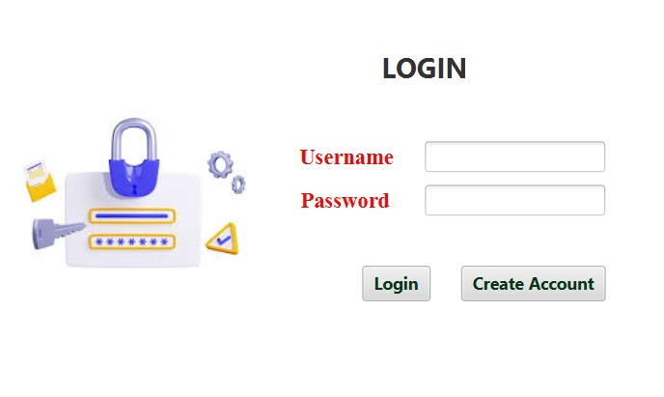

**7.2 CREATE ACCOUNT PAGE:**

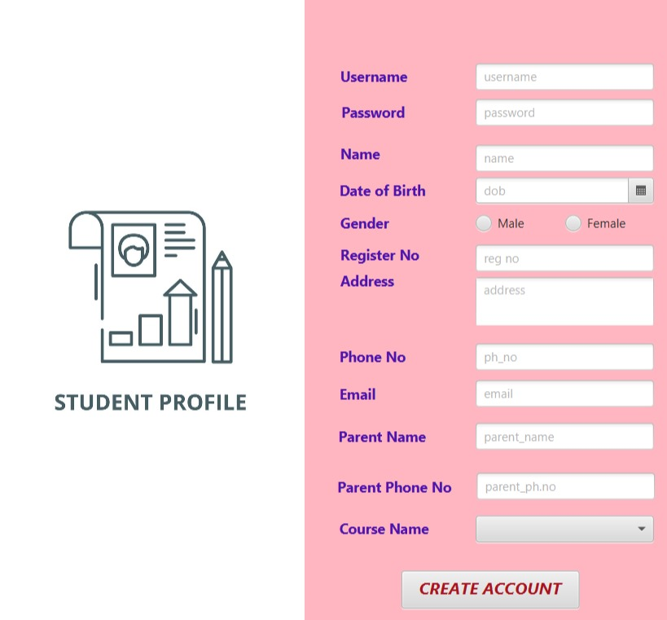

**7.3 COURSES LIST:**



**7.4 COURSE DETAILS:**



**7.5 ATTENDANCE DETAILS:**

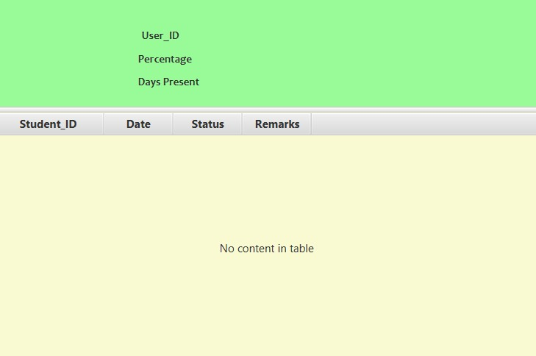

**CHAPTER 8**

# CONCLUSION AND FUTURE ENHANCEMENT

**Conclusion:**

The Database Connectivity Project for the Student Attendance Management System effectively establishes a secure and dynamic link with the MySQL database, facilitating streamlined data storage, retrieval, and management. Key modules, including user authentication, attendance information retrieval, enrollment and progress tracking, instructor class management, leave request processing, profile updates, and communication integration, form a solid foundation for an intuitive and responsive attendance management platform. This project prioritizes security, scalability, and real-time interaction, enhancing the overall user experience for students, instructors, and administrators in effectively managing and monitoring student attendance.

# Future Enhancement:

Future enhancements for the Student Attendance Management System include the implementation of predictive analytics to identify attendance trends early on, automated notifications based on analytics, and the development of an adaptive leave management system. Utilizing data visualization techniques, exploring IoT for attendance tracking, and integrating biometric authentication contribute to increased accuracy and security. Additionally, introducing gamification elements, a dedicated mobile app, and voice recognition further enhance student engagement and accessibility. The system's evolution includes an automated summary feature for instructors to quickly grasp attendance trends.

# REFERENCES:

[1] https://[www.ispringsolutions.com/blog/student-attendance-project-](http://www.ispringsolutions.com/blog/elearning-project-) management

[2] https://[www.studocu.com/in/document/i-k-gujral-punjab-technical-](http://www.studocu.com/in/document/i-k-gujral-punjab-technical-) university/project-ii/attendance-management-website-project-report/42574508

[3] https://[www.studocu.com/in/document/i-k-gujral-punjab-technical-](http://www.studocu.com/in/document/i-k-gujral-punjab-technical-) university/project-ii/attendance-management-website-project-report/42574508

[4]https://[www.researchgate.net/publication/221366020_Design_and_](http://www.researchgate.net/publication/221366020_Design_and_) Development_of_an_Student_attendance_Management_System